**Lab 7 Activity 1 - Understanding the Excel Interface**

**Objective:** Learn the essential components of MS Excel and basic cell operations.

1. Open MS Excel and create a new workbook.

2. Identify and explore the Ribbon, Formula Bar, Cells, Rows, and Columns.

3. Enter sample data into a few cells and experiment with resizing columns and rows.

4. Save the file with an appropriate name.

**____________________________________________________________________________________**

**Solutions:**

**Task 1:**

* Open Microsoft Excel on your computer.
* 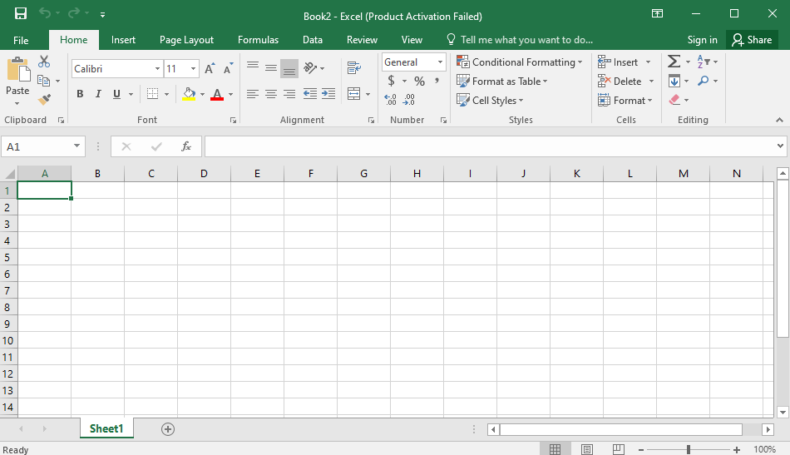Click on Blank Workbook to create a new spreadsheet.

**Task 2:**

Familiarize yourself with the key components:

1. Ribbon – Located at the top, contains tabs like Home, Insert, Page Layout, Formulas, Data, Review, View.
2. Formula Bar – Found below the Ribbon, used to enter and edit data/formulas in a selected cell.
3. Cells – Small rectangular boxes where you enter data (e.g., A1, B2, C3).
4. Rows – Numbered (1, 2, 3 ...) along the left side.
5. Columns – Labeled with letters (A, B, C ...) at the top.

**Task 3:**

* Click on Cell A1 and type: Name
* Click on Cell B1 and type: Age
* Click on Cell C1 and type: City
* Move your cursor to the line between Column A & B (at the top).
* Click and drag to widen or narrow the column.
* Similarly, adjust row height by dragging the line between two row numbers**.**

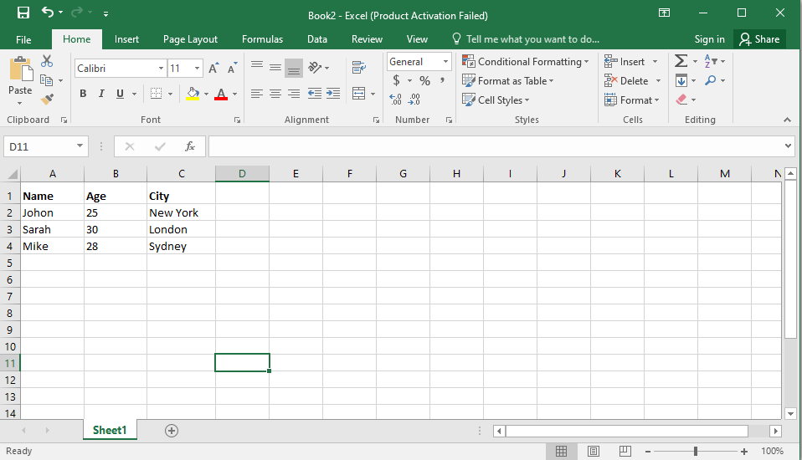

**Task 4:**

* Click **File** > **Save As**.
* Choose a location (e.g., **Documents** or **Desktop**).
* Name the file, e.g., **Excel_Practice.xlsx**.
* Click **Save**.